These are the libraries that have been used in the program in Implementing the example 2 “**APPLE SHARES PREDICTION**”

* NumPy
* Matplotlib
* Pandas
* Surround

Let us see in detail about these libraries

**NumPy:**

NumPy is considered as one of the most popular machine learning libraries in Python. Many popular libraries use NumPy internally for performing multiple operations on Tensors. Array interface is the best and the most important feature of NumPy.

Features Of NumPy

1. **Interactive:** NumPy is very interactive and easy to use.
2. **Mathematics:** Makes complex mathematical implementations very simple.
3. **Intuitive:** Makes coding real easy and grasping the concepts is easy.
4. **Lot of Interaction:** Widely used, hence a lot of open source contribution.

Where Is NumPy Used?

This interface can be utilized for expressing images, sound waves, and other binary raw streams as an array of real numbers in N-dimensional.For implementing this library for machine learning having knowledge of NumPy is important for full stack developers. So we have used this library for number plots in our example for calculation.

**Mat Plot Lib:**

Matplotlib is a Python 2D plotting library which produces publication quality figures in a variety of hardcopy formats and interactive environments across platforms.

Matplotlib tries to make easy things easy and hard things possible. You can generate plots, histograms, power spectra, bar charts, error charts, scatterplots, etc., with just a few lines of code.

For example we will be using line plot to show the output in the example program so here's how to create a line plot with text labels using [plot()](https://matplotlib.org/api/_as_gen/matplotlib.pyplot.plot.html#matplotlib.pyplot.plot).

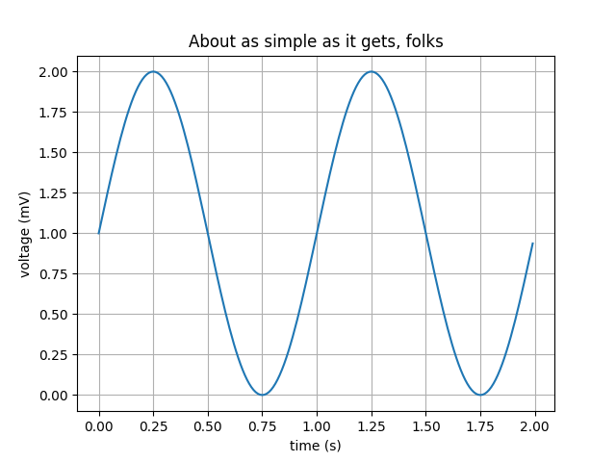

Sample plot

**Pandas:**

This is also one of the popular libraries that provides data structures of high-level and a wide variety of tools for analysis. One of the great features of this library is the ability to translate complex operations with data using one or two commands. Pandas have so many inbuilt methods for grouping, combining data, and filtering, as well as time-series functionality.

We have decided to use pandas because they make sure that the entire process of manipulating data will be easier. Support for operations such as Re-indexing, Iteration, Sorting, Aggregations, Concatenations and Visualizations are among the feature highlights of Pandas. This will help us to represent examples better

Data Analysis among everything else takes the highlight when it comes to usage of Pandas. But, Pandas when used with other libraries and tools ensure high functionality and good amount of flexibility.

**Surround**

Surround is on of the upcoming python libraries recently and is known for its flexibility in helping data engineers exploit data with better understanding of predicted data process, the process divides process into 4 stages, stage 1 initiates the data feeding to the process, stage 2 normalises the fed data, stage 3 is data prediction of the data with minimal error rate and stage 4 is plotting of graph of the predicted data for better understanding of the output